Methodologies on Data Collection and OCR Table Extraction

Abstract

The data collection methods aimed to digitize and extract information from historical water documents, focusing on California datasets from the 1970s and 1980s. The pipeline involved downloading, processing, and detecting tables from large PDF archives using Python, image conversion tools, and Microsoft's Table Detection Model. OCR techniques, including Google Tesseract and PaddleOCR, were applied to digitize and identify table structures. However, complex tables posed challenges in accurately recognizing columns. Post-processing methods, alongside OpenCV, were explored to improve results. The project culminated in a working prototype utilizing both Microsoft and PaddleOCR models to extract and validate data efficiently.

About the Data
Diagram 1. Project Flow
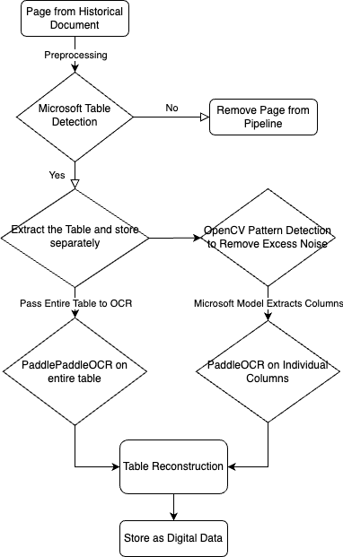
The data was sourced from United States Geological Survey (USGS) historical water documents, specifically California water records from the 1970s and 1980s. These documents were downloaded as PDFs using a Python web scraper. The PDFs were converted into images using the Python Imaging Library (PIL) and OpenCV, and the data was stored as image (.png) files within the UCSB Grit cluster.

Methods

Step 1. Preprocessing
Before passing the images to Microsoft’s Table Detection model, they are standardized. The preprocessing steps included:
  - Grayscale Conversion: Simplifies the image to one channel.
  - Gaussian Blur: Reduces noise to make edges smoother with a 3x3 kernel.
  - Contrast Enhancement: Improves the visibility of details.
  - Max Resize: Resizes the image for easier processing and visualization
New images are stored as gray-scale single-channel images.

Step 2. Microsoft Table Detection
After denoising the images, the Microsoft Table Transformer model [1] was applied to detect the existence of tables. The model returned a truth value between 0 and 1 and the table bbox. The truth value represents the confidence score the model gave to each image, where 1 signifies a table exists and 0 signifies no table. The bbox is the coordinates of the detected table in the image.

Terminology:
- Threshold: a value between 1 and 0 such that all results with truth values less than threshold value are considered as no tables.
- False Positive: model detects table but, in truth, no table exists.
- False Negative: model does not detect table, but there is actually a table.
- Accuracy: correct prediction of tables/all predictions
- Validation Set: documents with known locations of tables in 19,147 images.

Step 2(a). Data Selection
Of course, not all truth values above 0 signifies 0. The next logical step is to determine an appropriate threshold to filter out the false positives. The table detection algorithm initially, with a threshold of 0.5, retained tables with 83% accuracy based on validation set analysis. However, the model returned that 16,000 of the 19,147 images were tables (very high false positives). We hypothesized that a higher threshold will lead to less false positives but lower accuracy as well. From here, we performed 3 additional trials, threshold values of 0.8, 0.75, and 0.65. Firstly, the model outputs with a threshold of 0.65 are nearly identical to the results from a threshold value of 0.5. Next, we tried a threshold of 0.8 on the validation; the model marked 13,712 images with tables and the accuracy fell to 80%. However, we found that a 0.75 threshold filter was ideal, lowering the false positive further by finding only 9,882 tables with a 79% accuray. Therefore, a threshold of 0.75 was used to separate images containing tables from those without.
If a table was detected, the image was cropped and stored in a separate dataset. Otherwise, the image was removed from the OCR pipeline.

Step 2(b). Column Extraction
Despite the preprocessing, some noise remained in the data. More specifically, images had pixel grains scattered throughout the image array. OpenCV’s pattern recognition was used to remove fixed or recognizable noise (Figure 2).
After this step, individual columns were extracted from the table structure using the Microsoft Table Transformer. These columns were stored separately to improve OCR results.
At this stage, two datasets were generated: one containing entire tables and another containing individual columns.

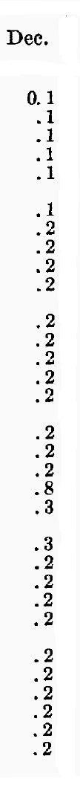
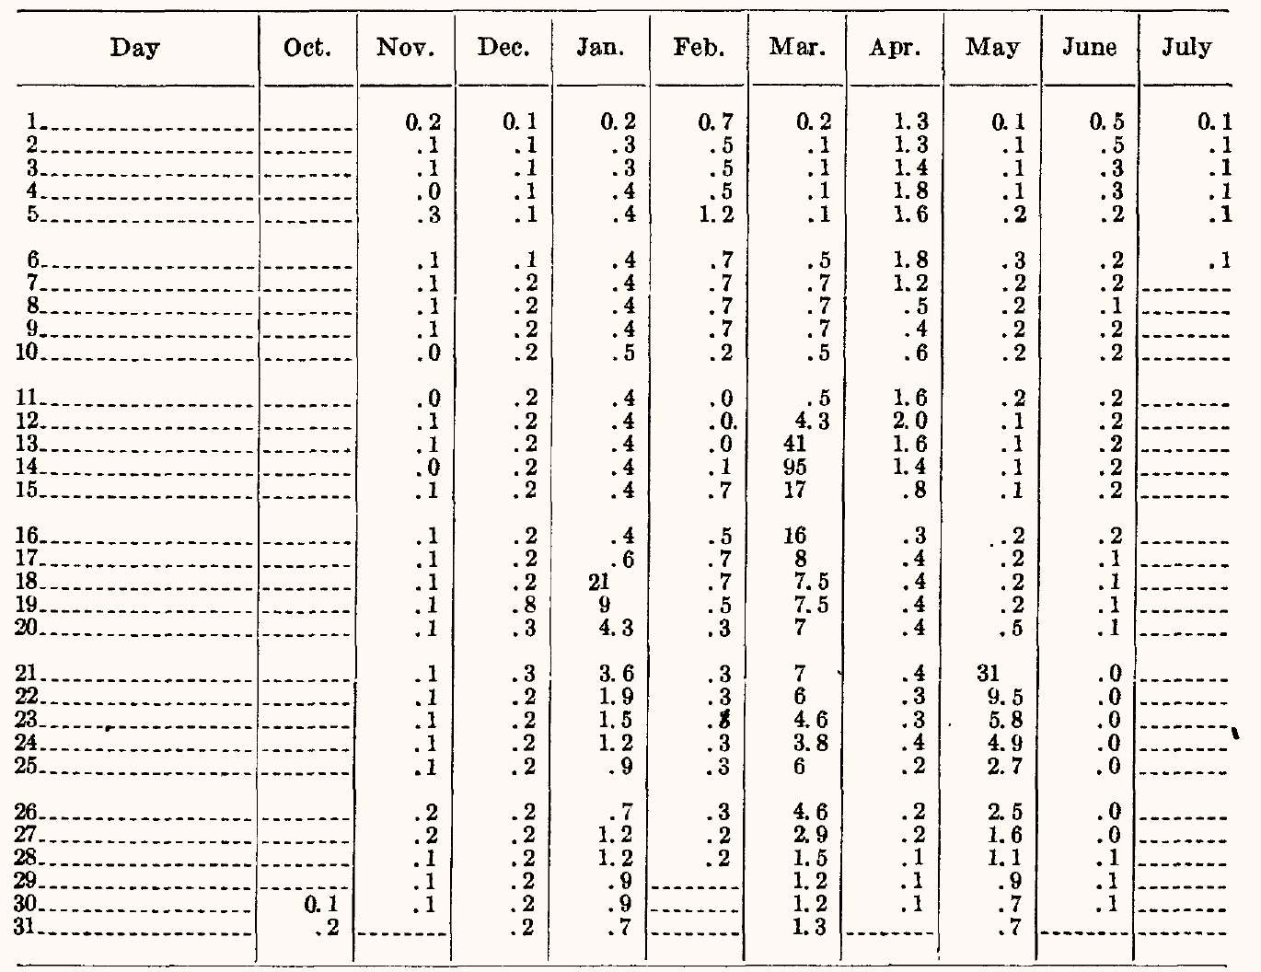
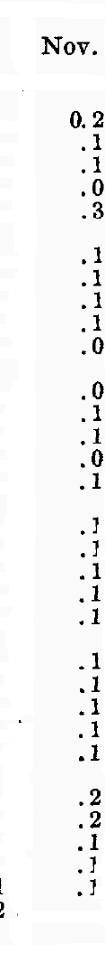
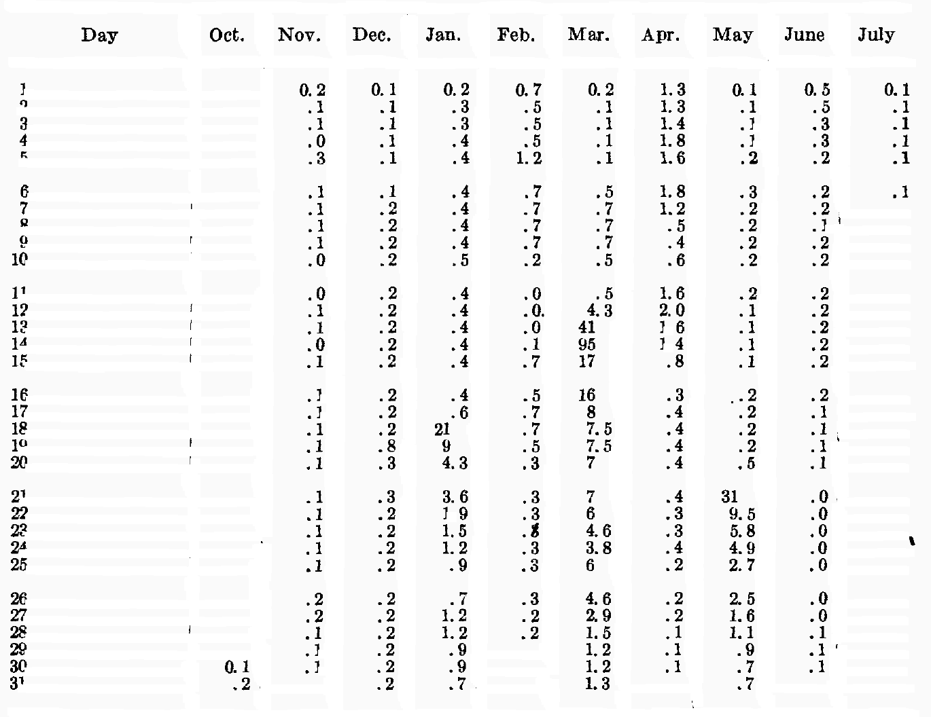

Figure 2. Image with noise (left), OpenCV noise reduced entire image(middle), and extract columns (right).

Step 3. Optical Character Recognition (OCR)

We utilize the pre-trained OCR model PaddleOCR [2] to perform our image-to-text conversions.

Step 3(a). PaddleOCR on Entire Tables
Processing entire tables generated mixed results. The table structure was preserved, but the data itself was distorted.

Step 3(b). PaddleOCR on Individual Columns
Processing individual columns produced clean, ordered data but lost the cohesive table structure. Since the columns were processed independently, they represented table components rather than complete tables.

Step 4. Reconstruction of Tables
To restore the complete tables, post-processing steps were applied:

- Extract the data from sorted columns into Pandas
- Restore the each column as CSV files
- Open raw CSV files
- Extract cells from the columns by white space
- Reconstruct the column cell by cell
- Repeat 2-5 with the rest of the columns
- Reconstruct table with post-processed columns as one CSV file.

This iterative process created a digitized library of tables from the image data. However, some structural elements were lost in the initial PaddleOCR conversion, leaving gaps in the data.

PaddleOCR Table Structure and Data Validation
Using 13 types of tables within the documents, we hand digitized the information stored within the table to create a pseudo-validation set. Then, we produced the predicted outputs for these tables using the process outlined in steps 1-4. Comparing the predicted outputs to the validation outputs, the accuracy of predicted outputs were less than ideal. However, this is due to the loss of structure in the tables through paddleOCR. Thus, we opted for a different validation approach; we matched data points within the individual columns while neglecting the column headers and locations. Through this, we found that 92% of data value was correct. This validation is based upon flawed assumptions and we were not able to validate the accuracy of table structure; however, it successfully communicates the areas in which more work can be done.

Future Works and Further Data Preservation
While Step 3(a) preserved the table structure better than Steps 3(b) and 4, combining these approaches may yield an even more accurate representation of the data. The variability of data in historical documents suggests that a self-trained model could be useful for future projects, although it would require significantly more resources.

References

[1]
[2]
[3]

